Name:T.Harshitha

Date:05/01/2023

Python Codes

Problem Statement 1

Valid Palindrome

A phrase is a **palindrome** if, after converting all uppercase letters into lowercase letters and removing all non-alphanumeric characters, it reads the same forward and backward. Alphanumeric characters include letters and numbers.

Given a string s, return true if it is a ***palindrome***, or false otherwise.

**Example 1:**

**Input:** s = "A man, a plan, a canal: Panama"

**Output:** true

**Explanation:** "amanaplanacanalpanama" is a palindrome.

**Example 2:**

**Input:** s = "race a car"

**Output:** false

**Explanation:** "raceacar" is not a palindrome.

Source Code:

 def isPalindrome(s):

        y=""

        for i in s:

            if i.isdigit() or i.isalpha():

                y=y+i.lower()

        if y==y[::-1]:

            return True

        return False

OUTPUT:

PROB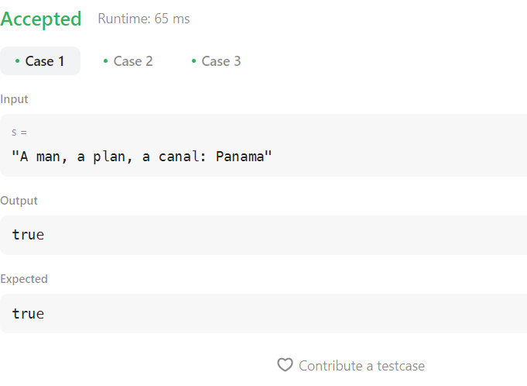

PROBLEM STATEMENT 2

 First Unique Character in a String

Given a string s, find the first non-repeating character in it and return its index. If it does not exist, return -1.

**Example 1:**

**Input:** s = "leetcode"

**Output:** 0

**Example 2:**

**Input:** s = "loveleetcode"

**Output:** 2

**Example 3:**

**Input:** s = "aabb"

**Output:** -1

Source Code

def firstUniqChar(s):

        chr_count = Counter(s)

        for x in chr_count:

            if chr_count[x]== 1:

                return s.index(x)

        return -1

OUTPUT:

